Link Spam
- Web Spam
- Spamming.
- Spammers – add text more times to the page or change the color of the text to the background
- Spam Farming – to increase the page rank of the page
- Link Spamming
  - Inaccessible Pages
  - Accessible Pages – link comments, blogs which allow ppl to comment
  - Own Pages

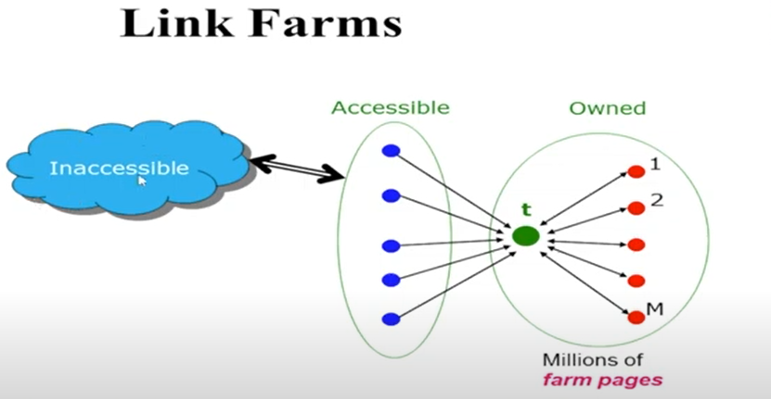

Let’s walk through a worked example of TrustRank in action to detect link spam. We'll use a simplified scenario with a few pages to illustrate how TrustRank helps identify and filter out spammy links.
Example Scenario:
Pages and Links:
- Seed Sites (Trusted Sources):
  - Site A: Trusted Government Site
  - Site B: Trusted Educational Institution
- Pages to Evaluate:
  - Page X: Trusted Blog
  - Page Y: News Article
  - Page Z: Spammy Blog
- Link Structure:
  - Site A links to Page X.
  - Site B links to Page X.
  - Page X links to Page Y.
  - Page Y links to Page Z.
  - Page Z has many links from low-quality or irrelevant sites.
Step-by-Step TrustRank Calculation:
1. Initial TrustRank Assignment:
- Site A and Site B are seed sites with the highest TrustRank, let’s assign them TrustRank scores of 1.0.
- Page X is linked by both seed sites, so it starts with a high TrustRank score.
2. Propagation of TrustRank:
- Page X inherits TrustRank from Site A and Site B. Assuming equal contribution:
  - Page X’s initial TrustRank = (TrustRank from Site A + TrustRank from Site B) / Number of Seed Sites
  - TrustRank(Page X) = (1.0 + 1.0) / 2 = 1.0 (normalized)
3. Propagation to Other Pages:
- Page X links to Page Y:
  - Page Y’s TrustRank is partially derived from Page X’s TrustRank.
  - Assuming Page X has 100% trust passed to Page Y:
    - TrustRank(Page Y) = Page X’s TrustRank × fraction of TrustRank distributed (e.g., 0.5 if Page X links to 2 pages evenly)
    - TrustRank(Page Y) = 1.0 × 0.5 = 0.5
- Page Y links to Page Z:
  - Page Z inherits a portion of Page Y’s TrustRank:
    - TrustRank(Page Z) = Page Y’s TrustRank × fraction of TrustRank distributed (e.g., 0.25 if Page Y links to 2 pages evenly)
    - TrustRank(Page Z) = 0.5 × 0.25 = 0.125
4. Detection of Link Spam:
- Page Z has a TrustRank of 0.25 because it received trust from Page Y, which in turn received trust from Page X (a trusted source).
- Page Z also has many links from low-quality or irrelevant sites. The TrustRank it receives from these spammy sources doesn’t increase its score significantly.
- If Page Z had high PageRank but low TrustRank, it indicates that while it may have many inbound links (possibly from spammy sources), it doesn’t inherit significant trust from reputable sites.
5. Analysis of Results:
- Page Z, despite having potentially high PageRank due to many inbound links, has low TrustRank because it doesn’t get direct links from seed sites and relies heavily on lower-trust links.
- This discrepancy signals that Page Z might be engaging in link spam. It has inflated PageRank from low-quality sources, but its actual trustworthiness is low.
Summary of TrustRank in Spam Detection:
- TrustRank propagates trust from trusted seed sites to other pages.
- Pages directly linked by seed sites receive higher TrustRank.
- TrustRank decays with each hop from the seed sites.
- Pages with high PageRank but low TrustRank are likely to be flagged for spam.
By applying this method, search engines can more effectively identify and reduce the impact of link spam, ensuring that trustworthy, high-quality pages rank higher in search results.

TrustRank is closely related to link spam detection as it helps identify and mitigate the effects of spammy link-building practices. Here’s a detailed explanation of how TrustRank relates to link spam:
How TrustRank Helps Detect Link Spam
- TrustRank’s Propagation of Trust:
  - Seed Sites: TrustRank begins with a set of seed sites that are manually identified as highly trustworthy (e.g., major educational institutions, government sites).
  - Propagation: TrustRank is propagated from these trusted seed sites to other web pages based on the link structure. Pages directly linked by trusted seed sites inherit high TrustRank scores, while pages farther from these trusted sources receive lower scores.
- Decay of Trust:
  - Distance from Seed Sites: The TrustRank value decays as it propagates through links. Pages that are multiple steps away from trusted seed sites will have lower TrustRank values.
  - Spammy Pages: Spammy pages are often linked primarily by other low-quality or spammy sites and are less likely to receive direct links from trusted seed sites. This results in a low TrustRank.
- Link Spam Identification:
  - High PageRank, Low TrustRank: Pages that have high PageRank but low TrustRank are often indicative of link spam. These pages may achieve high PageRank due to numerous links from low-quality or spammy sites, but they lack actual trustworthiness because they don’t receive links from trusted sources.
  - Artificial Inflation: Spammers often create networks of sites that link to each other to artificially inflate their PageRank. However, since these links are not from trusted sources, the TrustRank of these spammy pages remains low.
  - Detection of Manipulative Practices: Pages with high PageRank but low TrustRank might be engaged in manipulative link practices, such as link farms, where links are exchanged in large volumes among low-quality sites.
Example Revisited
In the numerical example provided earlier:
- Page X received high TrustRank from trusted seed sites (Site A and Site B) and propagated this trust to Page Y.
- Page Y further propagated trust to Page Z. However, Page Z had many links from low-quality sites but not from the trusted seed sites.
- As a result, Page Z had a high PageRank due to its extensive link network but a low TrustRank, indicating it likely engaged in spammy link-building practices.
Summary
- TrustRank helps identify link spam by measuring the trustworthiness of pages based on their link structure relative to trusted seed sites.
- Pages with low TrustRank but high PageRank are flagged as potential spam, as their high PageRank is not supported by genuine trustworthiness.
- TrustRank balances the impact of high PageRank pages by ensuring that trust is propagated from trusted sources, making it easier to detect and reduce the influence of spammy or manipulative pages in search results.

Link Spam Detection: A Worked Example Using PageRank and TrustRank
Understanding the Problem: Link spam refers to the practice of manipulating link structures to artificially inflate the search engine ranking of a website. This can be done through various techniques, such as creating link farms, buying links, or exchanging links.
Example Scenario: Imagine a website named "ShadyDeals" that wants to improve its search engine ranking. They decide to create a network of low-quality websites (link farm) that solely link to ShadyDeals. These websites might have minimal content, but they will consistently link to ShadyDeals.
Detection Methods:
- PageRank:
  - Calculation: PageRank assigns a numerical value to each web page based on the number and quality of incoming links. Pages with more high-quality incoming links have a higher PageRank.
  - Detection: In the ShadyDeals example, the link farm would artificially boost ShadyDeals' PageRank, making it appear more important than it actually is. However, PageRank alone might not be sufficient, as spammers can devise strategies to manipulate it.
- TrustRank:
  - Calculation: TrustRank is a modification of PageRank that incorporates a notion of "trust." It starts with a set of trusted seed pages (e.g., reputable news websites) and propagates trust through the link structure.
  - Detection: If ShadyDeals receives a significant amount of trust from the link farm, it might raise suspicion. TrustRank can help identify websites that are artificially boosted by untrustworthy sources.
Worked Example:
- Seed Pages: Identify a set of trusted seed pages, such as Google News, Wikipedia, and major newspapers.
- Graph Construction: Create a graph where nodes represent web pages and edges represent links.
- Trust Propagation: Start with the seed pages and propagate trust to linked pages. Each page's trust score is influenced by the trust of its incoming links.
- Suspicious Patterns: If ShadyDeals receives a high trust score primarily from the link farm, it's likely a sign of link spam. Additionally, analyze the content of the link farm websites. If they have minimal original content or are solely focused on linking to ShadyDeals, it's further evidence of spam.
Additional Considerations:
- Link Quality: Evaluate the quality of links based on factors like anchor text, relevance, and the overall reputation of the linking website.
- Content Analysis: Examine the content of the target website and compare it to the content of its incoming links. Inconsistent or irrelevant content might indicate link spam.
- Behavioral Patterns: Monitor website behavior for unusual activity, such as sudden increases in traffic or backlinks.
- Machine Learning: Employ machine learning algorithms to analyze large datasets of web pages and identify patterns associated with link spam.
By combining these techniques and considering various factors, search engines can effectively detect and mitigate link spam, ensuring that search results remain relevant and unbiased.

A Numeric Example of Link Spam Detection
Scenario:
- Website A: A legitimate website with high-quality content and a strong backlink profile.
- Website B: A spam website created solely to boost the ranking of Website C.
- Website C: The target website trying to manipulate its ranking.
Initial PageRank:
- Website A: 0.25
- Website B: 0.05
- Website C: 0.10
Link Structure:
- Website B links to Website C.
- Website C links to Website A.
Calculating PageRank Iteration:
- Website A: 0.25 * (1 - 0.85) + 0.85 * (0.10 / 1) = 0.2375
- Website B: 0.05 * (1 - 0.85) + 0.85 * (0) = 0.0075
- Website C: 0.10 * (1 - 0.85) + 0.85 * (0.05 / 1) = 0.10375
After Multiple Iterations:
- Website A: 0.2375
- Website B: 0.0075
- Website C: 0.10375
Analysis:
- While Website C's PageRank has increased slightly, it's not significantly higher than Website A, which has a more natural backlink profile.
- Website B's low PageRank indicates its low quality and lack of authority.
- If Website C were to receive a large number of links from similar low-quality websites, its PageRank would increase dramatically, raising suspicion of link spam.
TrustRank:
- Assuming Website A is a trusted seed page, it would propagate trust to Website C.
- Website B, being a low-quality spam site, would not propagate much trust.
- A significant difference in trust between Website A and Website C would indicate potential link spam.
Additional Factors:
- Anchor Text: If most links to Website C use spammy keywords or exact-match anchor text, it's a red flag.
- Content Quality: If Website C has low-quality, keyword-stuffed content, it's more likely to be involved in spam.
- Link Farm Detection: Tools can identify networks of low-quality websites that solely link to a target site, indicating a link farm.
By considering these factors and using algorithms like PageRank and TrustRank, search engines can effectively detect and penalize websites involved in link spam.

